Worksheet No. 3

Student Name: ANINDITA DHAR UID: 25MCA20259
Branch: MCA (GENERAL) Section/Group: MCA- 1-A
Semester: II Date of Performance: 27/01/2026
Subject Name: Technical Training Subject Code: 25CAP-652

1.Aim/Overview of the practical:
To implement conditional decision-making logic in PostgreSQL using IF–ELSE constructs and CASE expressions for classification, validation, and rule-based data processing.

2. Objectives:
- To understand conditional execution in SQL.
- To implement decision-making logic using CASE expressions.
- To simulate real-world rule validation scenarios.
- To classify data based on multiple conditions.
- To strengthen SQL logic skills required in interviews and backend systems.

3. Input/Apparatus Used:
- PostgreSQL
- pgAdmin

4. Practical / Experiment Steps
- Create a table that stores:
- A unique identifier
- A schema or entity name
- A numeric count representing violations or issues
- Populate the table with multiple records having different violation counts.

Classifying data using a CASE expression
- Retrieve schema names and their violation counts.
- Use conditional logic to classify each schema into categories such as:
- No Violation
- Minor Violation
- Moderate Violation
- Critical Violation

Applying CASE Logic in Data Updates
- Add a new column to store approval status.
- Update this column based on violation count using conditional rules such as:
- Approved
- Needs Review
- Rejected

Implementing if-else logic using PL/SQL
- Use a procedural block instead of a SELECT statement.
- Declare a variable representing violation count.
- Display different messages based on the value of the variable using IF–ELSE logic.
- Create a table to store student names and marks.
- Classify students into grades based on their marks using conditional logic.

Using CASE for custom sorting
- Retrieve schema details.
- Apply conditional priority while sorting records based on violation severity.
4.Procedure/Algorithm/Code:

- Start the system and log in to the computer.

ii. Open PostgreSQL software.

iii. Create a table using the DDL command.

CREATE TABLE Schema_Analysis (

schema_id SERIAL PRIMARY KEY,

schema_name VARCHAR(100),

violation_count INT

);

iv. Insert records into the table named customer_orders.

INSERT INTO Schema_Analysis VALUES(1,'Employee_Schema',0);

INSERT INTO Schema_Analysis VALUES(2,'Payroll_Schema',2);

INSERT INTO Schema_Analysis VALUES(3,'Inventory_Schema',5);

INSERT INTO Schema_Analysis VALUES(4,'Finance_Schema',1);

vi. Display all records.

SELECT * FROM Schema_Analysis;

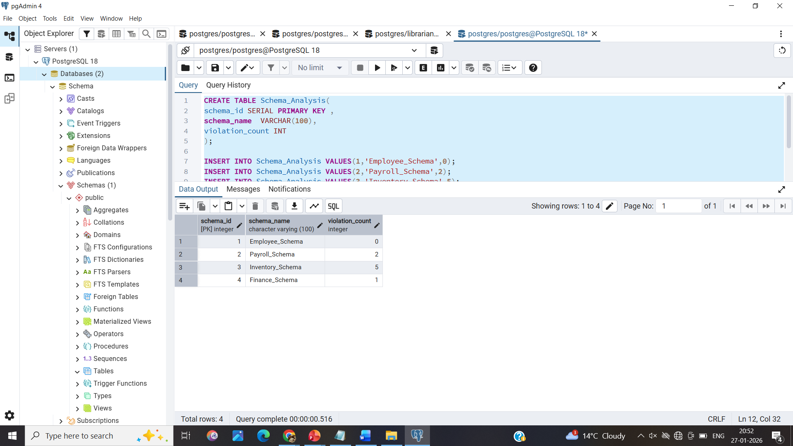

vii. Classifying data using a CASE expression

SELECT

schema_id,

schema_name,

violation_count,

CASE

WHEN violation_count = 0 THEN 'No Violation'

WHEN violation_count BETWEEN 1 AND 2 THEN 'Minor Violation'

ELSE 'Critical Violation'

END AS Violation_category

FROM Schema_Analysis;

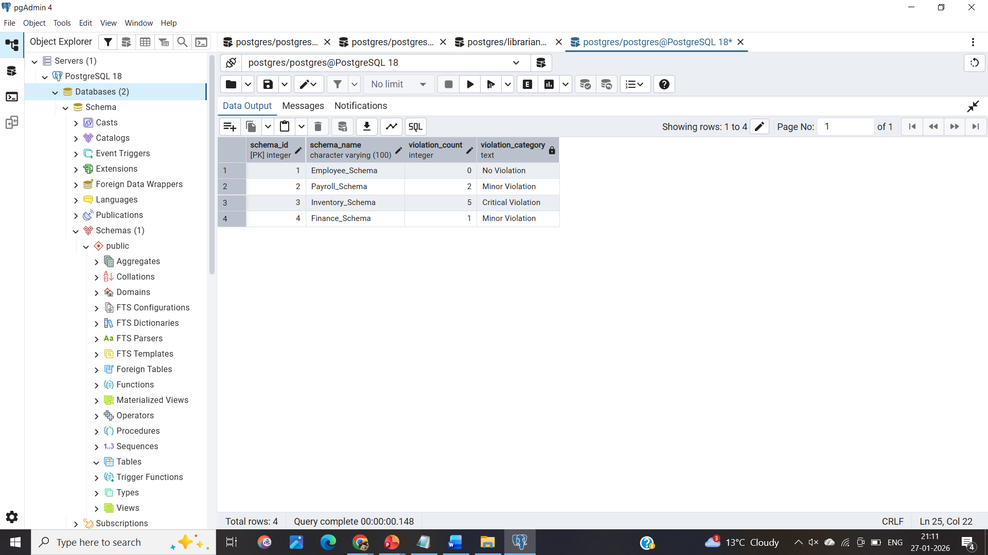

viii. Applying CASE Logic in Data Updates
ALTER TABLE Schema_Analysis
ADD Status VARCHAR(100);

UPDATE Schema_Analysis
SET Status = CASE
WHEN violation_count = 0 THEN 'APPROVED'
WHEN violation_count BETWEEN 1 AND 2 THEN 'REVIEW'
ELSE 'REJECTED'
END;

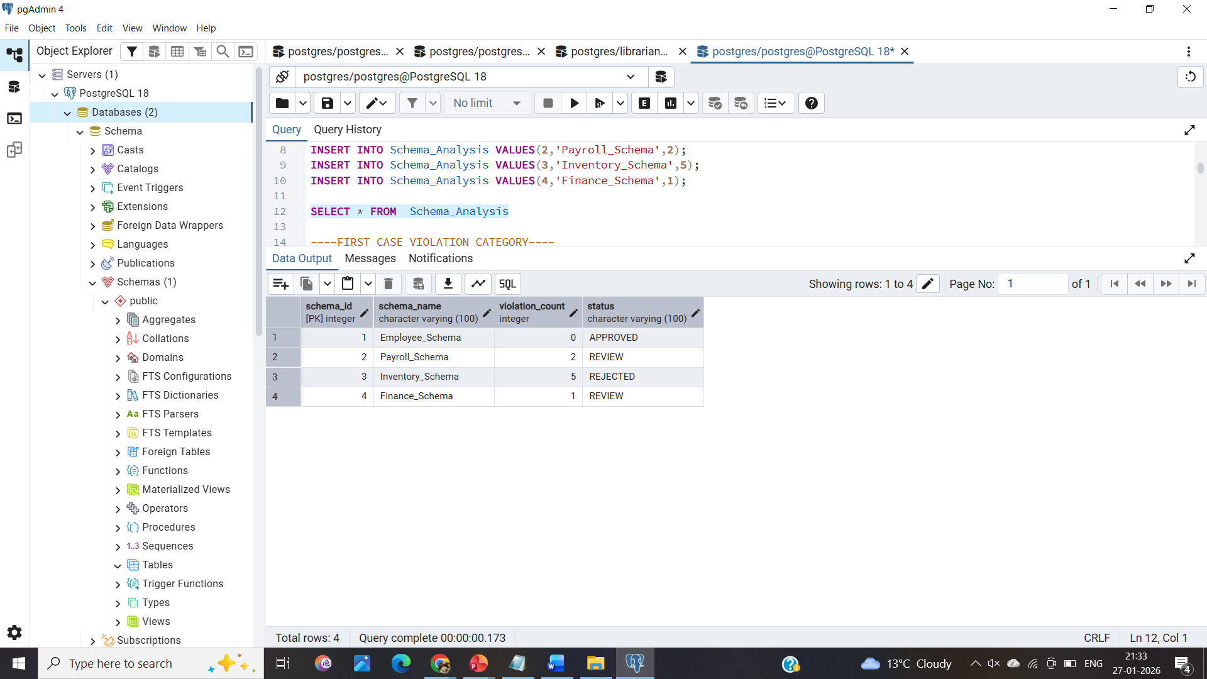

ix. Implementing if-else logic using PL/SQL
DO $$
DECLARE
VAL INT := 2;
BEGIN
IF VAL > 10 THEN
RAISE NOTICE 'Value greater than 10';
ELSIF VAL BETWEEN 10 AND 50 THEN
RAISE NOTICE 'Value is between 10 and 50';
ELSE
RAISE NOTICE 'Value less than 10';
END IF;
END $$;

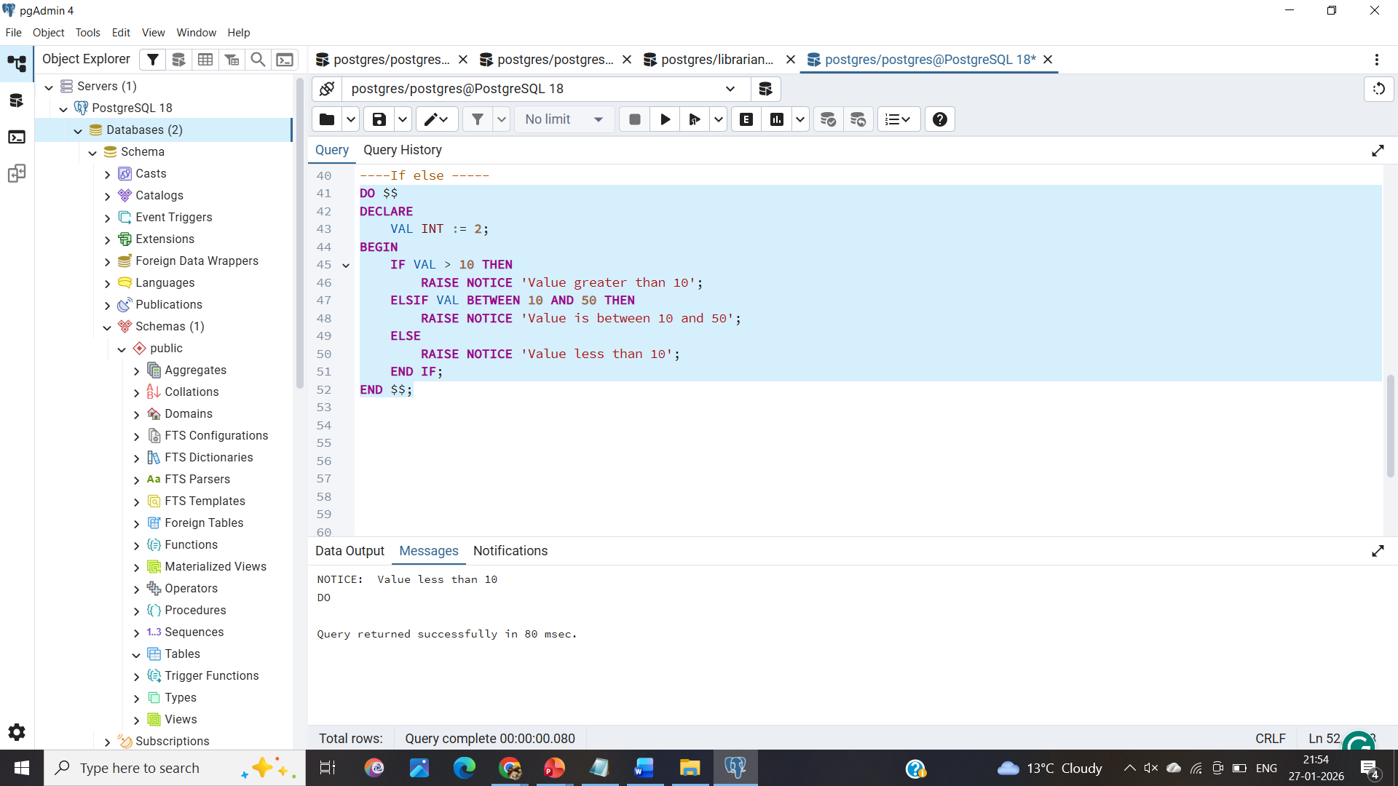

x. Create a table to store student names and marks.
CREATE TABLE Students_1(
student_names VARCHAR (100),
student_marks INT
);

xi. Classify students into grades based on their marks using conditional logic.
CREATE TABLE IF NOT EXISTS students_12(
id SERIAL PRIMARY KEY,
name VARCHAR(100),
marks INTEGER CHECK (marks >= 0 AND marks <= 100),
grade VARCHAR(2)
);

INSERT INTO students_12(name, marks) VALUES ('Anindita', 85);
INSERT INTO students_12(name, marks) VALUES('John', 92);
INSERT INTO students_12(name, marks) VALUES ('Alice', 65);
INSERT INTO students_12(name, marks)VALUES('Bob', 45);
INSERT INTO students_12(name, marks) VALUES('Eve', 78);

DO $$
DECLARE
student_rec RECORD;
student_grade VARCHAR(2);
BEGIN
-- Loop through students and assign grades
FOR student_rec IN SELECT id, name, marks FROM students_12 LOOP

-- Conditional logic for grades
CASE
WHEN student_rec.marks >= 90 THEN student_grade := 'A+';
WHEN student_rec.marks >= 80 THEN student_grade := 'A';
WHEN student_rec.marks >= 70 THEN student_grade := 'B';
WHEN student_rec.marks >= 60 THEN student_grade := 'C';
WHEN student_rec.marks >= 50 THEN student_grade := 'D';
ELSE student_grade := 'F';
END CASE;

-- Update grade
UPDATE students_12
SET grade = student_grade
WHERE id = student_rec.id;

RAISE NOTICE 'Student: %, Marks: %, Grade: %',
student_rec.name, student_rec.marks, student_grade;
END LOOP;
END $$;

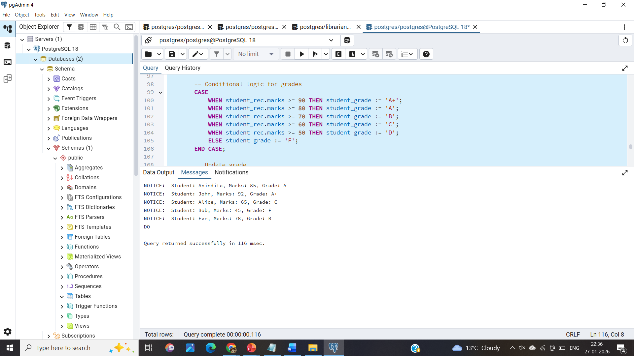
5. I/O Analysis (Input / Output Analysis)

- Creates 3 tables (Schema_Analysis, students_12 populated).
- Processes schema violations → status.
- Outputs 7 RAISE NOTICE messages.
- No errors; idempotent elements like IF NOT EXISTS and ON CONFLICT DO NOTHING handle re-runs safely.

6. Learning Outcomes:
- CASE Expression (SQL Level)
- UPDATE with CASE
- Loops & Record Processing
- Data Integrity

